## ***Design Patterns***

Illustrating code Snippet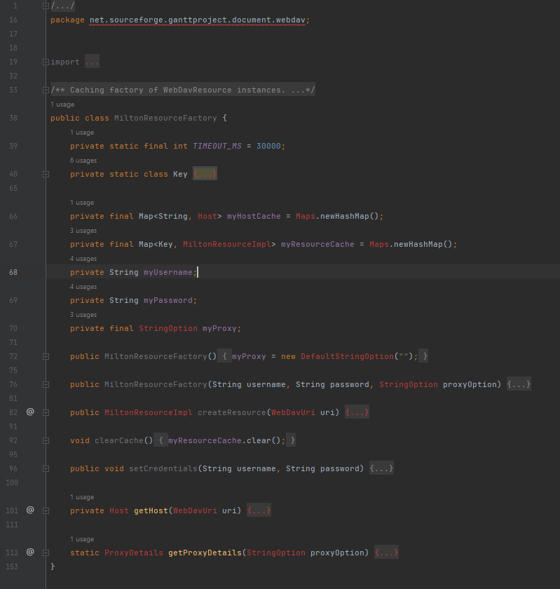

## **Class location:**

[ganttproject](https://github.com/Gui28F/ganttproject)/[ganttproject](https://github.com/Gui28F/ganttproject/tree/master/ganttproject)/[src](https://github.com/Gui28F/ganttproject/tree/master/ganttproject/src)/[main](https://github.com/Gui28F/ganttproject/tree/master/ganttproject/src/main)/[java](https://github.com/Gui28F/ganttproject/tree/master/ganttproject/src/main/java)/[net](https://github.com/Gui28F/ganttproject/tree/master/ganttproject/src/main/java/net)/[sourceforge](https://github.com/Gui28F/ganttproject/tree/master/ganttproject/src/main/java/net/sourceforge)/[ganttproject](https://github.com/Gui28F/ganttproject/tree/master/ganttproject/src/main/java/net/sourceforge/ganttproject)/[document](https://github.com/Gui28F/ganttproject/tree/master/ganttproject/src/main/java/net/sourceforge/ganttproject/document)/[webdav](https://github.com/Gui28F/ganttproject/tree/master/ganttproject/src/main/java/net/sourceforge/ganttproject/document/webdav)/MiltonResourceFactory.java

## **Design pattern:**

Here we have a “Factory” design pattern that has the purpose to hide the creation of instances of MiltonResourceImpl behind an interface

2.

Illustrating code snippet

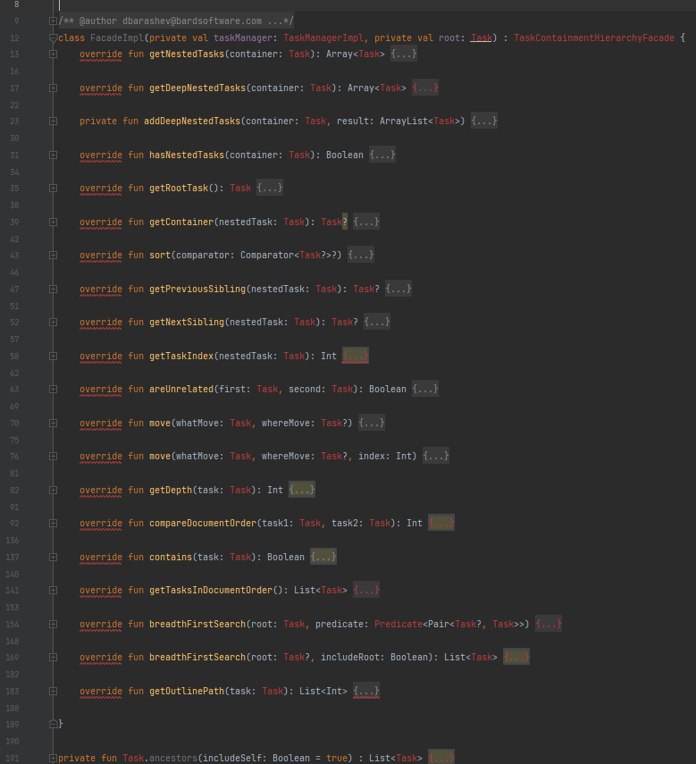

## **Class location:**

[ganttproject](https://github.com/Gui28F/ganttproject)/[ganttproject](https://github.com/Gui28F/ganttproject/tree/master/ganttproject)/[src](https://github.com/Gui28F/ganttproject/tree/master/ganttproject/src)/[main](https://github.com/Gui28F/ganttproject/tree/master/ganttproject/src/main)/[java](https://github.com/Gui28F/ganttproject/tree/master/ganttproject/src/main/java)/[net](https://github.com/Gui28F/ganttproject/tree/master/ganttproject/src/main/java/net)/[sourceforge](https://github.com/Gui28F/ganttproject/tree/master/ganttproject/src/main/java/net/sourceforge)/[ganttproject](https://github.com/Gui28F/ganttproject/tree/master/ganttproject/src/main/java/net/sourceforge/ganttproject)/[task](https://github.com/Gui28F/ganttproject/tree/master/ganttproject/src/main/java/net/sourceforge/ganttproject/task)/

TaskTreeFacade.kt

## **Design pattern:**

Here we have a “Façade” design pattern that encapsulates the whole Task tree.

3.

Illustrating code snippet: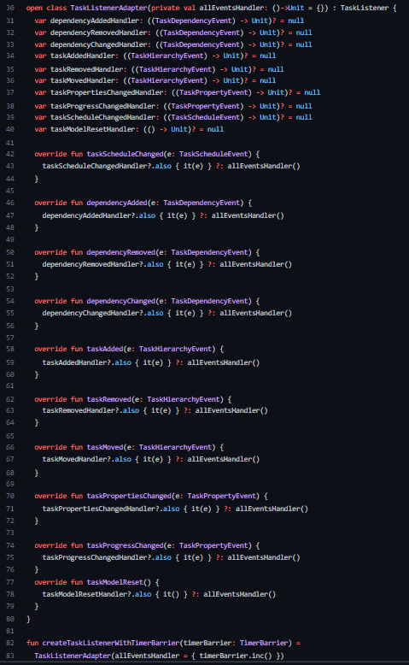

**Class location:**

[ganttproject](https://github.com/Gui28F/ganttproject)/[ganttproject](https://github.com/Gui28F/ganttproject/tree/master/ganttproject)/[src](https://github.com/Gui28F/ganttproject/tree/master/ganttproject/src)/[main](https://github.com/Gui28F/ganttproject/tree/master/ganttproject/src/main)/[java](https://github.com/Gui28F/ganttproject/tree/master/ganttproject/src/main/java)/[net](https://github.com/Gui28F/ganttproject/tree/master/ganttproject/src/main/java/net)/[sourceforge](https://github.com/Gui28F/ganttproject/tree/master/ganttproject/src/main/java/net/sourceforge)/[ganttproject](https://github.com/Gui28F/ganttproject/tree/master/ganttproject/src/main/java/net/sourceforge/ganttproject)/[task](https://github.com/Gui28F/ganttproject/tree/master/ganttproject/src/main/java/net/sourceforge/ganttproject/task)/[event](https://github.com/Gui28F/ganttproject/tree/master/ganttproject/src/main/java/net/sourceforge/ganttproject/task/event)/

TaskListenerAdapter.kt

## **Design pattern:**

Here we have a “Adapter” design pattern which facilitates the handling of the events by providing a compatible interface.